Exercise: Grouping data

Lab Instructions
Lucky Shrub is a medium-sized garden design firm that sells indoor and outdoor plants, making them a one stop shop for clients. In this lab, you must complete the following tasks to help Lucky Shrub group and filter grouped data for their reports using the GROUP BY and HAVING clauses.
The Orders table used for this lab contains the following data: OrderID, Department, OrderDate, OrderQty and OrderTotal as shown below.
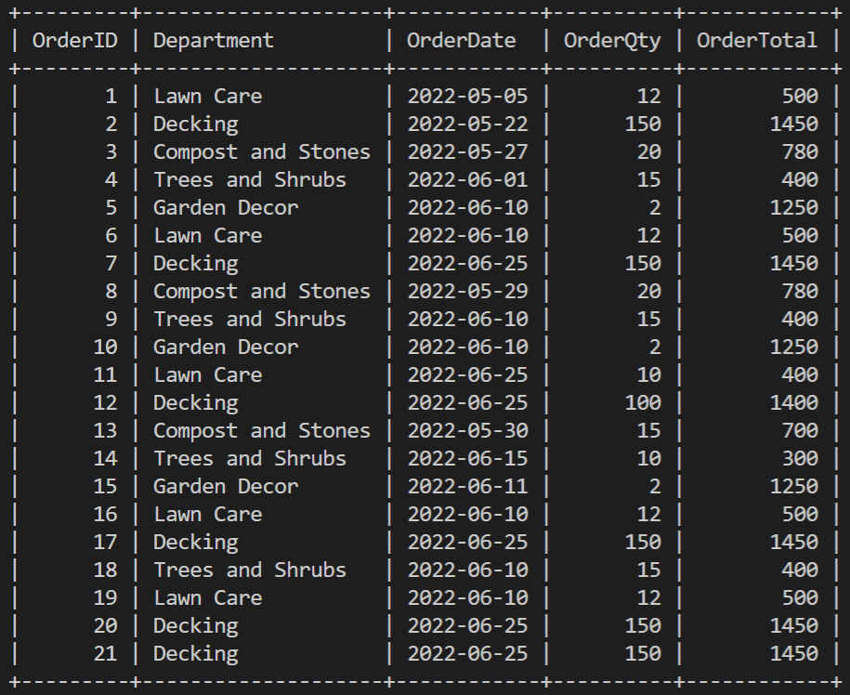list of department orders
Prerequisites
To complete this lab, you must have the Lucky Shrub database created in MySQL. You must also create and populate the Orders table with relevant data inside the Lucky Shrub database.
The code to create the database and the Orders table is as follows.
# 1: Create database
CREATE DATABASE luckyshrub_db;
# 2: Use database
USE luckyshrub_db;

# 3: Create Orders table
CREATE TABLE Orders(OrderID INT, Department VARCHAR(100), OrderDate DATE, OrderQty INT, OrderTotal INT, PRIMARY KEY(OrderID));

# 4: Insert data
INSERT INTO Orders VALUES(1,'Lawn Care','2022-05-05',12,500),(2,'Decking','2022-05-22',150,1450),(3,'Compost and Stones','2022-05-27',20,780),(4,'Trees and Shrubs','2022-06-01',15,400),(5,'Garden Decor','2022-06-10',2,1250),(6,'Lawn Care','2022-06-10',12,500),(7,'Decking','2022-06-25',150,1450),(8,'Compost and Stones','2022-05-29',20,780),(9,'Trees and Shrubs','2022-06-10',15,400),(10,'Garden Decor','2022-06-10',2,1250),(11,'Lawn Care','2022-06-25',10,400),
(12,'Decking','2022-06-25',100,1400),(13,'Compost and Stones','2022-05-30',15,700),(14,'Trees and Shrubs','2022-06-15',10,300),(15,'Garden Decor','2022-06-11',2,1250),(16,'Lawn Care','2022-06-10',12,500),(17,'Decking','2022-06-25',150,1450),(18,'Trees and Shrubs','2022-06-10',15,400),(19,'Lawn Care','2022-06-10',12,500),(20,'Decking','2022-06-25',150,1450),(21,'Decking','2022-06-25',150,1450);

This activity has two main objectives:
1. Group data using the GROUP BY clause.
2. Filter grouped data using the HAVING clause.

Exercise Instructions
Please attempt the following tasks:
Task 1: Write a SQL SELECT statement to group all records that have the same order date.
The expected output result should be the same as the following screenshot, assuming that you have created and populated the tables correctly.
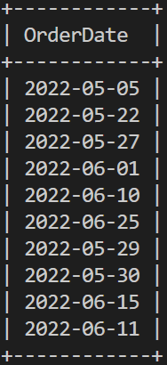
Task 2: Write a SQL SELECT statement to retrieve the number of orders placed on the same day.
The expected output result should be the same as the following screenshot assuming that you have created and populated the tables correctly.
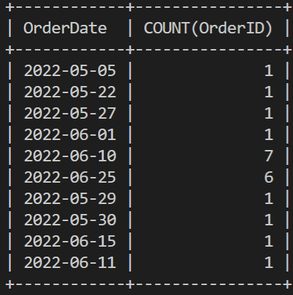
Task 3: Write a SQL SELECT statement to retrieve the total order quantities placed by each department.
The expected output result should be the same as the following screenshot assuming that you have created and populated the tables correctly.
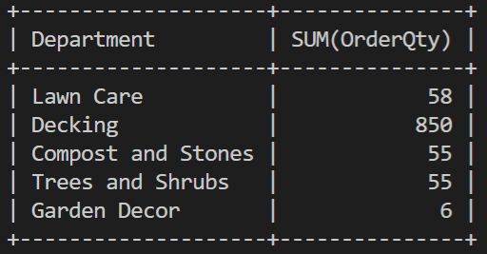
Task 4: Write a SQL SELECT statement to retrieve the number of orders placed on the same day between the following dates: 1st June 2022 and 30th June 2022.
The expected output result should be the same as the following screenshot assuming that you have created and populated the tables correctly.
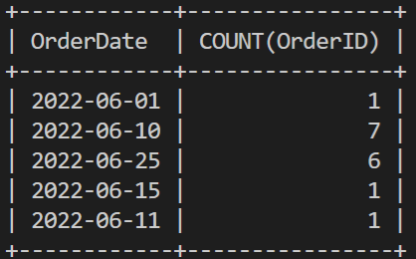

Additional resources
The following resources are additional reading materials that provide more information about how the GROUP BY and HAVING clauses work in MySQL:
- Overview of the GROUP BY and HAVING clause with relevant examples.
- Process steps for using the MySQL HAVING clause to specify a filter condition for groups of rows or aggregates.
- Introduction to the GROUP BY statement with relevant examples.

Video link:
https://www.youtube.com/watch?v=9HXJUGT-06w
https://www.youtube.com/watch?v=FztbYXeOEQ4&list=PLZPZq0r_RZOMskz6MdsMOgxzheIyjo-BZ&index=27

Reading exercise: Operators and clauses (Optional)
Lucky Shrub gardening center's database stores data on their employees, customer orders and the details of orders handled by employees.

Instructions
Prerequisites
You can use the following SQL scripts to set up the Employees_db in your local environment.
CREATE DATABASE Employees_db;
USE Employees_db;
CREATE TABLE employees (
EmployeeID int NOT NULL,
EmployeeName varchar(150) DEFAULT NULL,
Department varchar(150) DEFAULT NULL,
ContactNo varchar(12) DEFAULT NULL,
Email varchar(100) DEFAULT NULL,
AnnualSalary int DEFAULT NULL,
PRIMARY KEY (EmployeeID)
);

CREATE TABLE orders (
OrderID int NOT NULL,
Department varchar(100) DEFAULT NULL,
OrderDate date DEFAULT NULL,
OrderQty int DEFAULT NULL,
OrderTotal int DEFAULT NULL,
PRIMARY KEY (OrderID)
);

CREATE TABLE employee_orders (
OrderID int NOT NULL,
EmployeeID int NOT NULL,
Status VARCHAR(150),
HandlingCost int DEFAULT NULL,
PRIMARY KEY (EmployeeID,OrderID),
FOREIGN KEY (EmployeeID) REFERENCES employees(EmployeeID),
FOREIGN KEY (OrderID) REFERENCES orders(OrderID)
);

INSERT INTO employees VALUES
(1,'Seamus Hogan', 'Recruitment', '351478025', 'Seamus.h@luckyshrub.com',50000),
(2,'Thomas Eriksson', 'Legal', '351475058', 'Thomas.e@luckyshrub.com',75000),
(3,'Simon Tolo', 'Marketing', '351930582','Simon.t@luckyshrub.com',40000),
(4,'Francesca Soffia', 'Finance', '351258569','Francesca.s@luckyshrub.com',45000),
(5,'Emily Sierra', 'Customer Service', '351083098','Emily.s@luckyshrub.com',35000),
(6,'Maria Carter', 'Human Resources', '351022508','Maria.c@luckyshrub.com',55000),
(7,'Rick Griffin', 'Marketing', '351478458','Rick.G@luckyshrub.com',50000);

INSERT INTO orders VALUES(1,'Lawn Care','2022-05-05',12,500),
(2,'Decking','2022-05-22',150,1450),
(3,'Compost and Stones','2022-05-27',20,780),
(4,'Trees and Shrubs','2022-06-01',15,400),
(5,'Garden Decor','2022-06-10',2,1250),
(6,'Lawn Care','2022-06-10',12,500),
(7,'Decking','2022-06-25',150,1450),
(8,'Compost and Stones','2022-05-29',20,780),
(9,'Trees and Shrubs','2022-06-10',15,400),
(10,'Garden Decor','2022-06-10',2,1250),
(11,'Lawn Care','2022-06-25',10,400),
(12,'Decking','2022-06-25',100,1400),
(13,'Compost and Stones','2022-05-30',15,700),
(14,'Trees and Shrubs','2022-06-15',10,300),
(15,'Garden Decor','2022-06-11',2,1250),
(16,'Lawn Care','2022-06-10',12,500),
(17,'Decking','2022-06-25',150,1450),
(18,'Trees and Shrubs','2022-06-10',15,400),
(19,'Lawn Care','2022-06-10',12,500),
(20,'Decking','2022-06-25',150,1450),
(21,'Decking','2022-06-25',150,1450);

INSERT INTO employee_orders
VALUES(1,3,"In Progress",200),
(1,5,"Not Recieved",300),
(1,4,"Not Recieved",250),
(2,3,"Completed",200),
(2,5,"Completed",300),
(2,4,"In Progress",250),
(3,3,"In Progress",200),
(3,5,"Not Recieved",300),
(3,4,"Not Recieved",250),
(4,3,"Completed",200),
(4,5,"In Progress",300),
(4,4,"In Progress",250),
(5,3,"Completed",200),
(5,5,"In Progress",300),
(5,4,"Not Recieved",250),
(11,3,"Completed",200),
(11,5,"Completed",300),
(11,4,"Not Recieved",250),
(14,3,"Completed",200),
(14,5,"Not Recieved",300),
(14,4,"Not Recieved",250);

Examples of using ANY and ALL operators with the GROUP BY and HAVING clauses
The Lucky Shrub database contains a table called orders that stores data about orders placed by different departments.
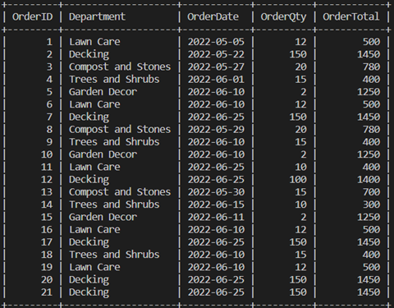
There’s also the employees table that stores data about Lucky Shrub’s employees.
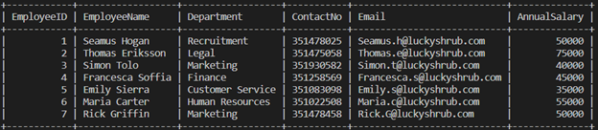
Finally, there’s an employee_orders table that stores data about the employees who are handling the orders.
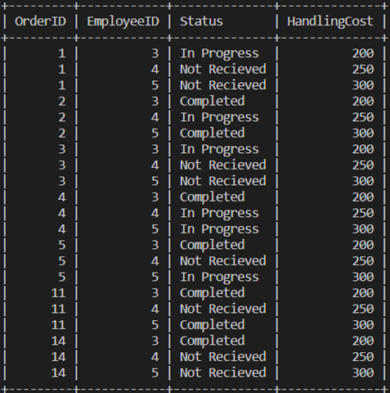

Tasks
Task1: Use the ANY operator to identify all employees with the Order Status status 'Completed'.
Task 2: Use the ALL operator to identify the IDs of employees who earned a handling cost of "more than 20% of the order value" from all orders they have handled.
Task 3: Use the GROUP BY clause to summarize the duplicate records with the same column values into a single record by grouping them based on those columns.
Task 4: Use the HAVING clause to filter the grouped data in the subquery that you wrote in task 3 to filter the 20% OrderTotal values to only retrieve values that are more than $100.

Reference sheet: Operators and clauses
GROUP BY clause
Use the GROUP BY clause in a SELECT statement to group rows in a table(s) based on a given column(s) into summary rows or subgroups.
It is placed after the FROM clause. If there is a WHERE clause in your SELECT statement, it should be placed after the WHERE clause. After the GROUP BY keyword, place a list of comma-separated column names by which you want to group the data.
HAVING clause
If you also want to filter your grouped data, use the HAVING clause. You should be aware that the WHERE clause cannot filter grouped data. The HAVING clause should appear after the GROUP BY clause. In the HAVING clause, you can specify the filter condition(s) that needs to be applied to your grouped data.
ANY operator : The ANY operator lets you perform a comparison between a single column value and a range of other values. The range of values comes from the execution of a subquery.
The syntax of a statement that uses an ANY operator is as follows:
SELECT column_name(s)
FROM table_name
WHERE column_name comparison operator ANY
(SELECT column_name
FROM table_name
WHERE condition);

The ANY operator returns a boolean value following a comparison operation. It returns a TRUE value if ANY subquery values meet the given condition. In other words, the condition will be TRUE if the operation is true for any of the values in the range.
In this syntax, the ANY operator should be preceded by a column name and a comparison operator that operates on the column name against the set of values.
Standard comparison operators like =, <>, !=, >, >=, <, or <= can be used here.
ALL operator
Use the ALL operator for the same purpose as the ANY operator. However, the way it works is a little bit different. It returns a boolean value as a result of performing a comparison operation. It returns TRUE only if ALL subquery values meet the given condition. In other words, the condition will be TRUE only if the operation is true for all values in the range.
The syntax for the ALL operator is as follows:
SELECT column_name(s)
FROM table_name
WHERE column_name operator ALL
(SELECT column_name FROM table_name WHERE condition);
The syntax is interpreted in the same way as with ANY and the standard comparison operators can be used with it.

